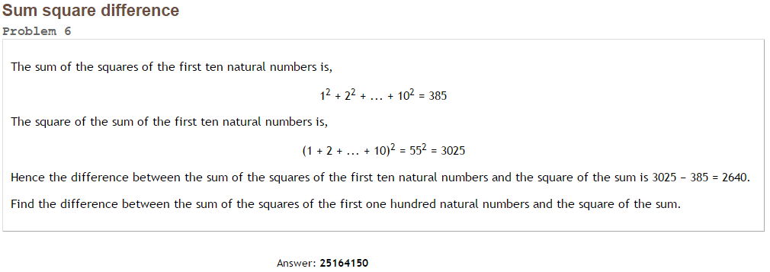Project Euler #6 – Pen & Paper Solution



When taking n=10, we get: [2460](http://www.wolframalpha.com/input/?i=n+*+%28n%2B1%29+*+%283n%5E2-n-2%29%2F12%2C+n+%3D+10)

When taking n=100, we get: [25164150](http://www.wolframalpha.com/input/?i=n+*+%28n%2B1%29+*+%283n%5E2-n-2%29%2F12%2C+n+%3D+100)